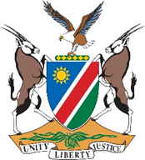

**REPUBLIC OF NAMIBIA**

**MINISTRY OF HEALTH AND SOCIAL SERVICES**

**Agenda**

**HEALTH INFORMATION SYSTEMS TECHNICAL WORKING GROUP MEETING**

**VENUE: PHC Boardroom, Ministerial Bulding Windhoek**

**DATE: 13 March 2025**

**TIME: 09:00 – 13:00**

**Chair Person:** Mr Erwin Nakafingo

|  |  |  |
| --- | --- | --- |
| **Time** | **Activity** | **Facilitator** |
| 08:45 – 09H00 | Arrival and Registration | Secretariat |
| 09:00 – 09:10 | Welcome and opening remarks | Mr Nakafingo |
| 09:10 –10:00 | HIS Data Collection Tools Revision |  |
| 10:00 – 11:00 | HIS Strategy |  |
| 11:00 – 11:30 | Statistical report |  |
| 11:30 – 12:30 | AOB |  |